**Programming Assignment #2 : UDP based Web server and client**

**Name:** 권도현

**Student ID:**2023065350

**Organization**: Department of computer science and engineering, Hanyang Univ. (Seoul, Republic of Korea)

**Introduction**

The Purpose of this programming assignment is to implement UDP web server and UDP web client. UDP is not connection-oriented and has a fast transmission speed. However, it does not guarantee reliable data transmission, so packet loss or ordering may occur during data transmission. Implement a UDP Server and UDP client that send requests with status messages and receive responses and make them act according to the status messages.

**Contents of the attachment**

**Mission 0: Before Start the Following Missions**

* 1. 1. Draw Block diagram of UDP Web Server & Web Client
  2. 라인, 폰트, 텍스트, 번호이(가) 표시된 사진

     자동 생성된 설명
  3. 2. Draw Flow chart for UDP Web Server & Web Client
  4. 텍스트, 스크린샷, 도표, 번호이(가) 표시된 사진

     자동 생성된 설명

**Mission 1: Establish a Connection**

* 1. 1. (Web Server) UDP Socket initialize for the web server: DatagramSocket
  2. 
  3. 2. (Web Server) Multi-Threaded UDP Web Server, Constructor Changed
  4. 텍스트, 스크린샷, 폰트, 라인이(가) 표시된 사진

     자동 생성된 설명
  5. 3. (Web Client) send datagram Packet with UDP socket to Web Server
  6. 

**Mission 2: UDP HTTP Request Handling**

* 1. 1. (Web Server) Translate Data to handle datagram
  2. 텍스트, 스크린샷, 폰트, 라인이(가) 표시된 사진

     자동 생성된 설명
  3. 2. (Web Client) Create HTTP Requset MSG and translate to datagram Packet.
  4. 텍스트, 스크린샷, 폰트이(가) 표시된 사진

     자동 생성된 설명

**Mission 3: UDP HTTP Response Message**

* 1. 1. (Web Server) Create response Message and translate to datagram to send with UDP
  2. 텍스트, 폰트, 스크린샷이(가) 표시된 사진

     자동 생성된 설명

2. (Web Client) receive datagramPacket and display.

**Running results**

I created test.html separately and used it.

**Instructions: How to run the program**

1. Run UDP Server
2. Run UDP client
   1. In this step, we can change request form.

**Wireshark**

1. Wireshark interface 중 Adapter for loopback traffic capture interface를 선택한다.
2. 필터: udp.port = 3000 (포트로 3000을 사용)

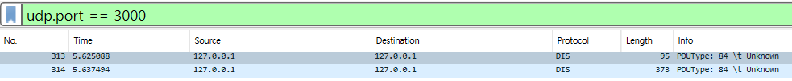

**How the program works**

1. **Server setting** 
   1. Initialize DatagramSocket.
   2. Waiting for UDP HTTP request.
2. **Client initialization**
   1. Create a socket.
   2. Set server address and port number.
   3. Sending HTTP request message.
3. **Request handling**
   1. Client: Waiting for HTTP response
   2. Server: Handle HTTP response according to Status code
      1. 200 OK: If requested file exists.
      2. 404 Not Found: If requested file does not exist.
      3. 501 Not Implemented: If the method is not implemented
4. **Concurrent Handling** 
   1. If there are multiple HTTP requests simultaneously, each JTTP request is processed in a separate thread.